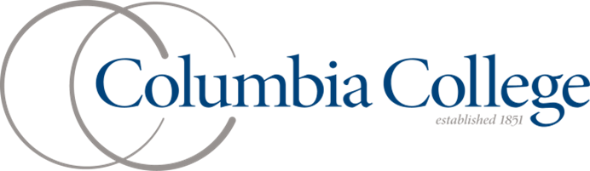**Computer Science Club**

***General Meeting***

***1-19-2012***

***Agenda***

* Club introductions

**Looking to the future…**

* Trip to Midway
* Resume building/internships
* Valentine’s Day
* Debugger tutorial
* Test-driven coding/Git Hub
* Exam help
  + What is the Computer Science Club?
  + Why do we exist?
  + What exactly goes on in the CS Club?
    - Tutoring – VM, C++, 170, etc.
    - High school visits
    - Service projects

**Upcoming Meetings**

2/21 – Student Affairs

2/28 – All Staff

3/7 – All Staff

3/14 – All Staff (Spring Break)

3/21 – Student Affairs

3/28 – No Meeting for Expo

4/4 – All Staff

4/11 – No Meeting for Recruitment

4/18 – Student Affairs

**Upcoming Meetings**

2/21 – Student Affairs

2/28 – All Staff

3/7 – All Staff

3/14 – All Staff (Spring Break)

3/21 – Student Affairs

3/28 – No Meeting for Expo

4/4 – All Staff

4/11 – No Meeting for Recruitment

4/18 – Student Affairs

* + - Programming review
    - Software tutorials
* How can I help with the CS Club?

**Include your group’s mission statement, purpose, goals or all of the above.**

* + T-shirts
  + Posters
    - Promotion of CS Club on campus
    - Advertising Computer Science to high schools
  + Sign up
* A word from our professors
  + Dr. Liow, Dr. Tourville, Dr. West, Dr. Zhuang, Dr. Warn
* 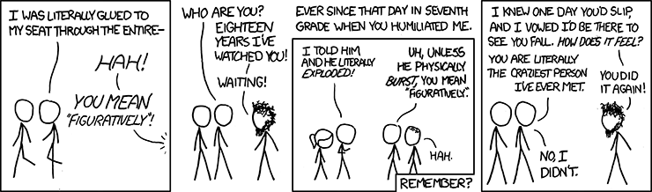Computer Lab visit

***Mark your calendar***

* General meetings
  + February – 2/2
  + March – 3/1

**Mission statement:** Columbia College Computer Science Club exists primarily to further the cause of the Computer Science Department of Columbia College. It shall be dedicated to providing Columbia College students with opportunities whereby they can advance their knowledge of the different branches of Computer and Information Sciences and get a hands-on experience with its various applications.

* + April – 4/5
  + May – 5/3

**Include your group’s mission statement, purpose, goals or all of the above.**